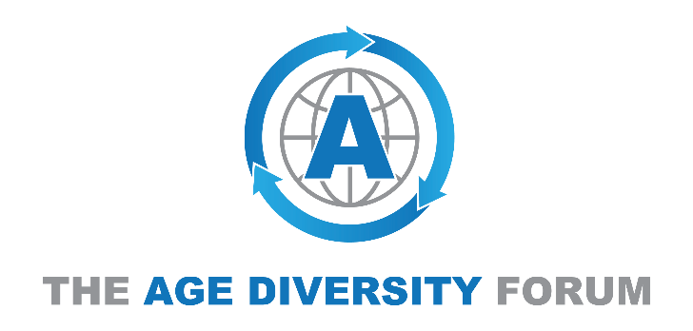

AGE DIVERSITY EVALUATION
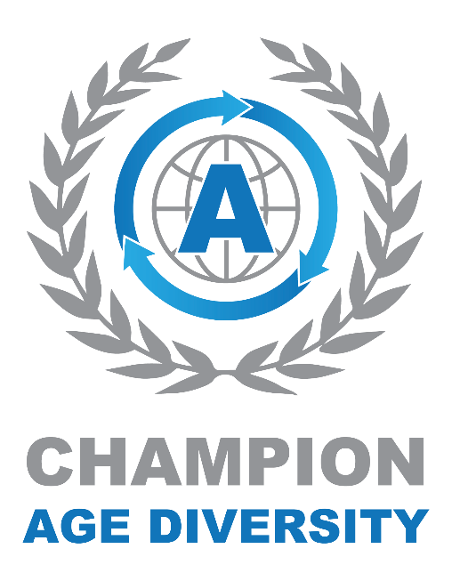
STAGE ONE

Working towards age diversity in the workplace

The Age Diversity Forum (ADF) works to ensure that organisations recognise and achieve the benefits and values of an age diverse workforce.

Nowadays the business case for diversity is more prominent, but unfortunately there continues to be challenges in breaking down barriers of age bias in the employment arena. This may be in the form of negative bias, unconscious or otherwise; a lack of opportunity for employers to access key skills and talent; poor retention and retraining programmes; or policy support requirements.

The ADF has designed a Champion membership environment to support and drive strategy and values for all organisations.

No industry sector is immune to these challenges, and none are restricted by geography.

We are a unique organisation with a vision for inclusion, to remove barriers through an application of practical service and best practice, achieved together with our ‘Champions’.

This questionnaire is the initial age diversity evaluation stage. Completing this questionnaire will enable us to provide you with feedback and recommendations in order to achieve the benefits of an age diverse workforce.

If you require assistance to complete the questionnaire, please contact the membership team.

Contact Name:

Role:

Email Address:

Telephone:

Organisation Name:

Location:

Number of Employees:

1: Policy & Governance
GUIDANCE: It is important for an organisation to have a diversity and inclusion(D&I) policy in place that also addresses the age demographics of the workplace.

- Do you have a D&I policy?

- If yes, do you have a policy for age diversity in the workplace?

MEMBERS HUB: The ADF members hub provides policy content and guidance for Champions which can be tailored and implemented for the organisation.

2: The Employee Lifecycle
GUIDANCE: It is important that an organisation has policies and support that addresses the development of staff, whatever their age, in the form of retention, training and recruitment processes.

- Do you have retention policies for all staff?

- Do you have training policies for all staff?

- Do you invest in recruitment practices that ensure the widest participation of candidates?

MEMBERS HUB: The ADF members hub has policy guidance for retention, training and recruitment, together with direct recruitment and resourcing functions that provide access to a wider demographic candidate base, that can be tailored for the organisation.

3: Leadership
GUIDANCE: It is vital that age diversity is recognised and actively promoted by the organisation’s Senior Leadership Team. This cuts across all the other sections, showing not only its employees that there is genuine support for age diversity but other businesses and the community as well.
- Who leads/sponsors the age diversity agenda for your organisation?

MEMBERS HUB: Create effective messaging and dissemination of values throughout the workforce.

4: Procurement
GUIDANCE: There is a real opportunity to include your supply chain and external partners to embrace age diversity, by building it into the procurement process. It can be included in contracts under ‘Social Value’ and can be as simple as making it known that you want those in your supply chain to commit to age diversity in their workplaces.
- Do you have diversity standards in your procurement process?

- Do you specify age diversity as a requirement?

MEMBERS HUB: Extend your diversity values to your supply chain partners to raise awareness and standards, so providing an improved value for money proposition.

5: Community Engagement
GUIDANCE: Champions have a role to play in promoting the age diversity agenda in the community. This may be part of social media strategy, public relations and communications strategies but however you do it, we actively encourage Champions to share their ‘good news’ stories about age diversity.
- Do you promote your diversity outlook to external partners and communities?

- Do you actively specify the age diversity agenda?

MEMBERS HUB: The ADF can provide outreach opportunities to ensure your diversity messages have the optimized positive impact.

6: Clients, Customers and Service Users
GUIDANCE: Champions also have a role to play in promoting the age diversity agenda to their clients, customers and service users and should explore what opportunities they have to do so.
- Do you promote your diversity outlook to your customers and consumers?

- Do you actively specify the age diversity agenda?

- Does your workforce reflect the age groups of your customer community?

MEMBERS HUB: Making progress towards an age diverse workforce provides a foundation for new product and service design that better reflects your existing customer base, whilst enhancing new market entry opportunities.

7: Monitoring
GUIDANCE: Commitment to age diversity is nothing without action and monitoring and a strategy should be in place to ensure all the measures to which a Champion has committed are implemented and actioned.
- Do you monitor the demographics of your workforce?

- Do you monitor the age profile of your workforce?

MEMBERS HUB: The ADF members hub offers monitoring and assessment support by providing you with a toolkit that will also form part of the ongoing evaluation process of your age diversity policies and practices. The purpose is to provide you with recognition of the standard to which you are promoting and embedding in to your workforce culture, and will help identify how and where further improvements and gains can be made.

8: Equality and Diversity
GUIDANCE: An attention to age diversity, uniquely, also provides inter-sectional access to other diversity and inclusion agenda, including gender, disability, LGBTQ, BAME, returners to work and local communities. More businesses and organisations are now planning their strategies for sustainability and growth, recognising the benefits and values gained from diversity in the workplace.
- Is age diversity one of your corporate values?

MEMBERS HUB: A focus towards the age agenda gives opportunity to consolidate and scale up positive impact to other D&I streams.

9: Free Comment
Please use this area for any other comments, including D&I areas that you currently do well, or where you think would require improvement/development :

Thank you for completing this brief questionnaire, which is designed to identify where you are on your pathway to achieving an age diverse workforce.
We will use the information that you have provided to explore the ways The Age Diversity Forum can assist you, and we will report back to you as soon as possible to help you develop your diversity programme and strategy.
Please send your completed questionnaire to info@agediversityforum.org

The Age Diversity Forum encourages organisations to adopt policies and behaviours that allows them to achieve the benefits of an age diverse workforce. The type of behaviours we are looking for organisations to adopt are as follows:
- has a clear age-diversity employment policy that is set out in your governing documents
- seeks to retain an age diverse workforce, giving balance to technical and life-skill attributes
- invests in your recruitment strategy to ensure that you are able to access all demographics when considering the search to fulfil a new vacancy
- will provide training, up-skilling and redeployment opportunities for all employees, whatever their age
- facilitates an improved culture of awareness, to encourage all staff to integrate and recognise the range of values provided across all employees

Beyond this initial evaluation stage, we work with ‘Champions’ via ‘deeper dive’ processes, for continued assessment and development mapping. It is accepted that organisations find themselves at different places on the route to achieving an age diverse work force that meets their particular business needs, but they can all be ‘Champions’, and showcase the ‘Champion’ mark!

